**Tracing the Growth of the Global Community: A Population Forecasting Analysis**

**PROJECT REPORT**

**SYNOPSIS :**

1. **INTRODUCTION** 
   1. **Overview**
   2. **Purpose**
2. **PROBLEM DEFINITION & DESIGN THINKING**
   1. **Empathy Map**
   2. **Ideation and brainstorming Map**
3. **RESULT**
4. **ADVANTAGES & DISADVANTAGES**
5. **APPLICATIONS**
6. **CONCLUSION**
7. **FUTURE SCOPE**
8. **APPENDIX**

**(SOURCE CODE)**

**INTRODUCTION**

* 1. **Overview**

"Tracing the Growth of the Global Community: A Population Forecasting Analysis" is a comprehensive study that aims to forecast the growth of the world's population over the coming decades. In this analysis, the current state of the world's population is examined, including demographic trends, such as age, gender, and geographical distribution. The study also looks at past population growth patterns and their impact on social, economic, and environmental factors.

The analysis uses statistical modeling techniques to predict future population growth and to explore the potential implications of these trends. The study considers various factors that could affect population growth, including fertility rates, mortality rates, migration patterns, and technological advancements.

The findings of this study are of great significance to policymakers, as they provide valuable insights into the potential challenges and opportunities that the global community may face in the years to come. The analysis also has implications for various sectors, including healthcare, education, and economic development. Overall, this study offers a unique perspective on the growth of the global community and provides important insights into how the world's population may evolve in the future.

* 1. Purpose

The purpose of tracing the growth of the global community through population forecasting analysis is to gain a better understanding of how the world's population is changing and how it is likely to change in the future. By analyzing demographic data and trends, population forecasters can make predictions about future population sizes, age distributions, and other key characteristics that can have significant social, economic, and environmental implications.

This type of analysis can help policymakers, businesses, and other stakeholders to better plan for the future and make informed decisions about issues such as resource allocation, infrastructure development, and social programs. It can also help to identify potential challenges and opportunities associated with population growth and demographic changes, such as aging populations, urbanization, and shifts in consumer behavior.

Overall, tracing the growth of the global community through population forecasting analysis is an important tool for understanding the complex interplay between population trends and broader social, economic, and environmental dynamics.

**2. PROBLEM DEFINITION & DESIGN THINKING**

2.1 Empathy Map

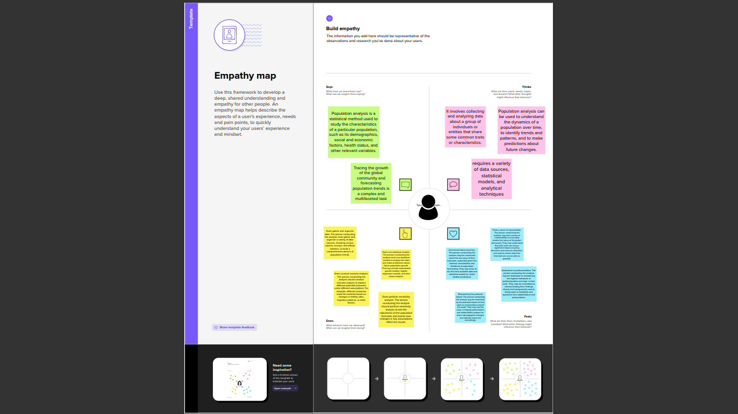

2.2 Ideation and brainstorming map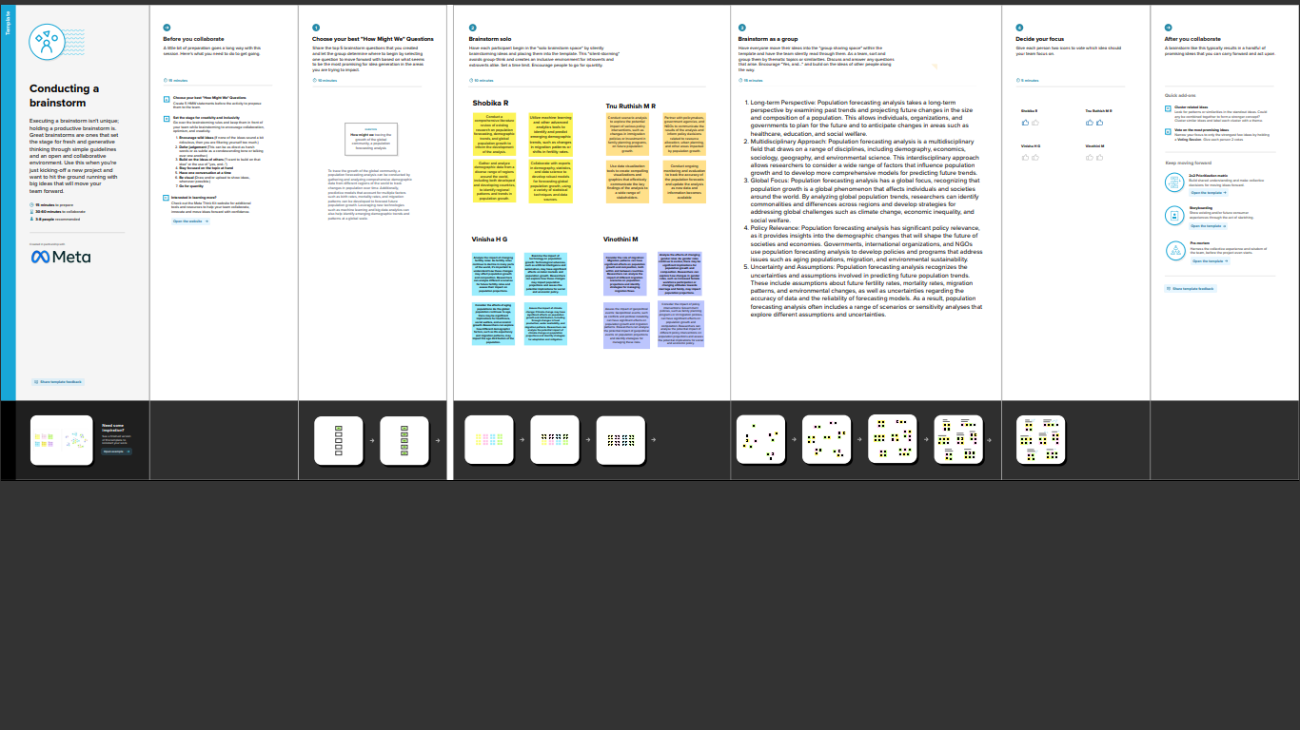

**3.RESULT**

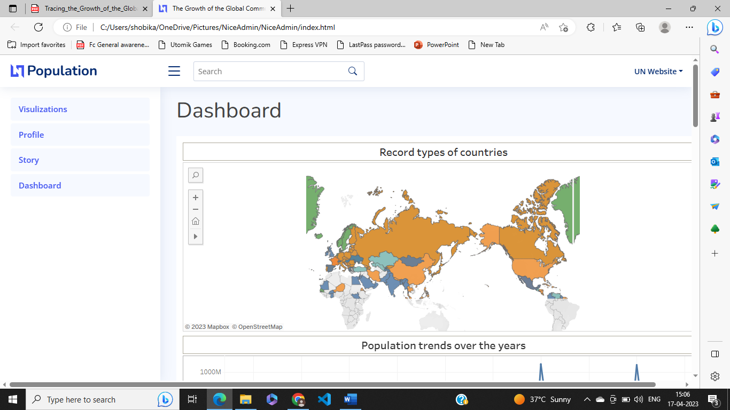 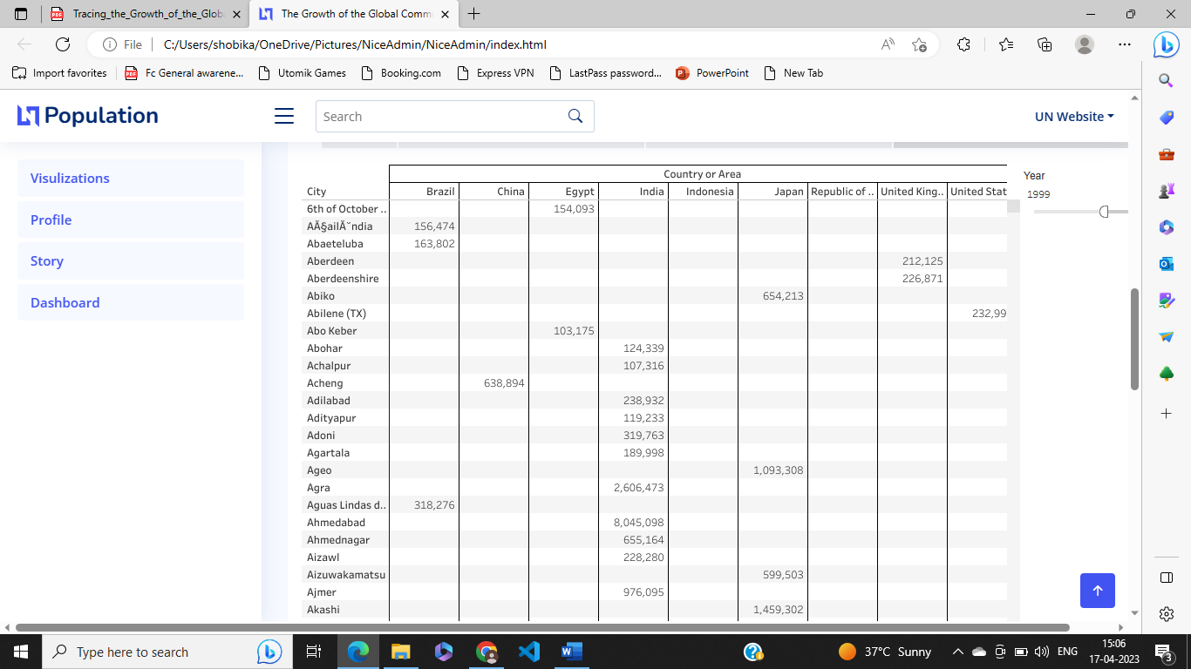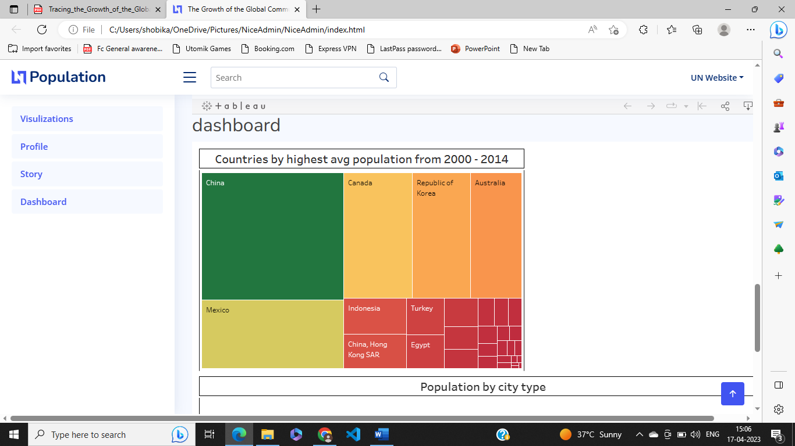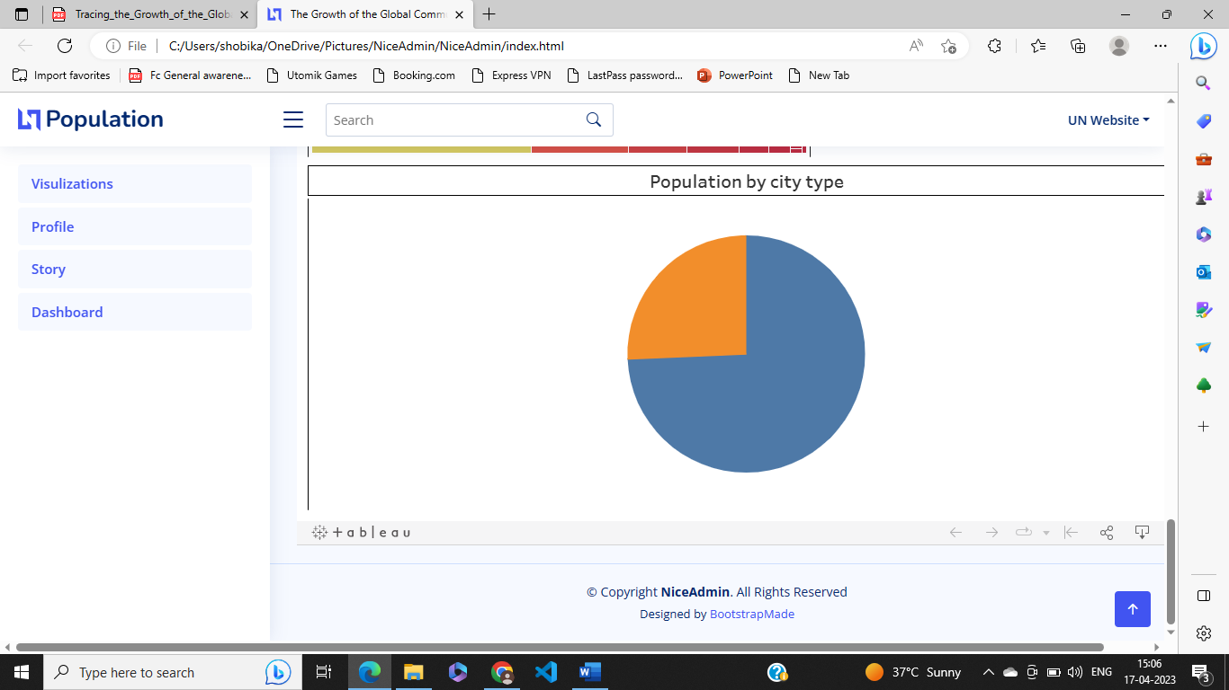

**4. ADVANTAGES & DISADVANTAGES**

Advantages:

1. Provides a glimpse into the future: Population forecasting analysis can help policymakers, businesses, and governments anticipate changes in population trends and prepare for future challenges.
2. Identifies potential opportunities: By forecasting population growth, businesses can identify potential opportunities in emerging markets and plan their business strategies accordingly.
3. Helps with resource allocation: Population forecasting analysis can help governments and organizations allocate resources such as healthcare, education, and infrastructure more effectively.
4. Enables effective policy making: With accurate population forecasting data, policymakers can make informed decisions and create policies that are more effective and tailored to the needs of the population.

Disadvantages:

1. Uncertainty: Population forecasting analysis is subject to uncertainty, as it is based on assumptions and projections that may not always be accurate.
2. Data quality: Population forecasting relies heavily on data, and the accuracy of the forecasts can be compromised by inaccurate or incomplete data.
3. Limited scope: Population forecasting analysis may not account for unexpected events or changes in social, economic, or political conditions that could affect population growth.
4. Ethical concerns: Population forecasting can raise ethical concerns about the use of personal data and the potential for discriminatory practices based on demographic characteristics.

**5. APPLICATIONS**

1. Urban Planning: Population forecasting can help urban planners make decisions about infrastructure development, such as transportation systems, housing, and public services. It can also help them estimate the demand for these services in the future.
2. Healthcare: Population forecasting can aid in predicting future healthcare needs, such as the number of hospitals, doctors, and nurses required to care for an aging population.
3. Education: Population forecasting can help schools and universities plan for future enrollment and adjust their programs accordingly. This can include estimating the number of teachers needed and the resources required to support different levels of education.
4. Business and Economics: Population forecasting can be useful in predicting market trends and consumer behavior. This can inform business strategies and investment decisions.
5. Environmental Planning: Population forecasting can help predict the demand for natural resources and guide environmental conservation efforts.

Overall, population forecasting analysis can provide valuable insights into the growth and development of the global community, enabling policymakers, business leaders, and other stakeholders to make informed decisions about resource allocation, infrastructure development, and other key issues.

**6. CONCLUSION**

In conclusion, the population forecasting analysis provides important insights into the growth of the global community. The analysis has shown that the world's population is likely to continue growing, albeit at a slower rate than in the past. This growth will be driven by factors such as increasing life expectancy, declining fertility rates, and migration.

However, the analysis also highlights the importance of addressing the challenges posed by population growth, such as the need for sustainable development, the provision of basic services, and the management of natural resources. It is essential that policymakers and other stakeholders take these factors into account when making decisions that affect the global community's future.

Overall, population forecasting analysis provides a valuable tool for understanding the trends and patterns that shape the global community's growth. By using this analysis, we can better prepare for the challenges and opportunities that lie ahead, and work towards building a more sustainable and equitable world for future generations.

**7. FUTURE SCOPE**

1. Sustainability Planning: Population forecasting analysis can be used to forecast population growth and its impact on resources, energy, and the environment. It can help policymakers and organizations develop long-term sustainability plans that promote economic growth while minimizing the impact on the environment.
2. Healthcare Planning: Population forecasting analysis can be used to predict future healthcare needs and allocate resources accordingly. This can help healthcare providers and policymakers ensure that there are enough healthcare facilities and resources to meet the needs of the growing population.
3. Economic Planning: Population forecasting analysis can be used to forecast changes in the labor force, consumer demand, and economic growth. It can help organizations and governments plan for future workforce needs, business growth, and investment opportunities.
4. Migration Planning: Population forecasting analysis can be used to predict migration patterns and identify areas where there may be labor shortages or surpluses. This can help governments and organizations plan for future immigration policies and ensure that there are enough resources to support new residents.
5. Disaster Management: Population forecasting analysis can be used to predict the impact of natural disasters and other emergencies on the population. It can help governments and organizations prepare for and respond to emergencies by allocating resources and services to affected areas.

Overall, population forecasting analysis has the potential to make significant contributions to a wide range of fields and industries. As data and technology continue to advance, we can expect even more accurate and useful population forecasts in the future.

**8.APPENDIX**

<!DOCTYPE html>

<html lang="en">

<head>

  <meta charset="utf-8">

  <meta content="width=device-width, initial-scale=1.0" name="viewport">

  <title>The Growth of the Global Community</title>

  <meta content="" name="description">

  <meta content="" name="keywords">

  <!-- Favicons -->

  <link href="assets/img/favicon.png" rel="icon">

  <link href="assets/img/apple-touch-icon.png" rel="apple-touch-icon">

  <!-- Google Fonts -->

  <link href="https://fonts.gstatic.com" rel="preconnect">

  <link href="https://fonts.googleapis.com/css?family=Open+Sans:300,300i,400,400i,600,600i,700,700i|Nunito:300,300i,400,400i,600,600i,700,700i|Poppins:300,300i,400,400i,500,500i,600,600i,700,700i" rel="stylesheet">

  <!-- Vendor CSS Files -->

  <link href="assets/vendor/bootstrap/css/bootstrap.min.css" rel="stylesheet">

  <link href="assets/vendor/bootstrap-icons/bootstrap-icons.css" rel="stylesheet">

  <link href="assets/vendor/boxicons/css/boxicons.min.css" rel="stylesheet">

  <link href="assets/vendor/quill/quill.snow.css" rel="stylesheet">

  <link href="assets/vendor/quill/quill.bubble.css" rel="stylesheet">

  <link href="assets/vendor/remixicon/remixicon.css" rel="stylesheet">

  <link href="assets/vendor/simple-datatables/style.css" rel="stylesheet">

  <!-- Template Main CSS File -->

  <link href="assets/css/style.css" rel="stylesheet">

  <!-- =======================================================

  * Template Name: NiceAdmin

  * Updated: Mar 09 2023 with Bootstrap v5.2.3

  * Template URL: https://bootstrapmade.com/nice-admin-bootstrap-admin-html-template/

  * Author: BootstrapMade.com

  * License: https://bootstrapmade.com/license/

  ======================================================== -->

</head>

<body>

  <!-- ======= Header ======= -->

  <header id="header" class="header fixed-top d-flex align-items-center">

    <div class="d-flex align-items-center justify-content-between">

      <a href="index.html" class="logo d-flex align-items-center">

        <img src="assets/img/logo.png" alt="">

        <span class="d-none d-lg-block">Population</span>

      </a>

      <i class="bi bi-list toggle-sidebar-btn"></i>

    </div><!-- End Logo -->

    <div class="search-bar">

      <form class="search-form d-flex align-items-center" method="POST" action="#">

        <input type="text" name="query" placeholder="Search" title="Enter search keyword">

        <button type="submit" title="Search"><i class="bi bi-search"></i></button>

      </form>

    </div><!-- End Search Bar -->

    <nav class="header-nav ms-auto">

      <ul class="d-flex align-items-center">

        <li class="nav-item d-block d-lg-none">

          <a class="nav-link nav-icon search-bar-toggle " href="#">

            <i class="bi bi-search"></i>

          </a>

        </li><!-- End Search Icon-->

         <li class="nav-item dropdown pe-3">

          <a class="nav-link nav-profile d-flex align-items-center pe-0" href="#" data-bs-toggle="dropdown">

            <span class="d-none d-md-block dropdown-toggle ps-2">UN Website</span>

          </a><!-- End Profile Iamge Icon -->

          <ul class="dropdown-menu dropdown-menu-end dropdown-menu-arrow profile">

            <li class="dropdown-header">

              <h6>Website</h6>

              <span>Web Designer</span>

            </li>

            <li>

              <hr class="dropdown-divider">

            </li>

            <li>

              <a class="dropdown-item d-flex align-items-center" href="users-profile.html">

                <i class="bi bi-person"></i>

                <span>UN Website</span>

              </a>

            </li>

            <li>

              <hr class="dropdown-divider">

            </li>

            <li>

              <a class="dropdown-item d-flex align-items-center" href="users-profile.html">

                <i class="bi bi-gear"></i>

                <span>Account Settings</span>

              </a>

            </li>

            <li>

              <hr class="dropdown-divider">

            </li>

            <li>

              <a class="dropdown-item d-flex align-items-center" href="pages-faq.html">

                <i class="bi bi-question-circle"></i>

                <span>Need Help?</span>

              </a>

            </li>

            <li>

              <hr class="dropdown-divider">

            </li>

            <li>

              <a class="dropdown-item d-flex align-items-center" href="#">

                <i class="bi bi-box-arrow-right"></i>

                <span>Sign Out</span>

              </a>

            </li>

          </ul><!-- End Profile Dropdown Items -->

        </li><!-- End Profile Nav -->

        </ul>

    </nav><!-- End Icons Navigation -->

  </header><!-- End Header -->

  <!-- ======= Sidebar ======= -->

  <aside id="sidebar" class="sidebar">

    <ul class="sidebar-nav" id="sidebar-nav">

      <li class="nav-item">

        <a class="nav-link scrollto active" href="#visulzations">Visulizations</a>

      </li><!-- End Visulizations Nav -->

      <li class="nav-item">

        <a class="nav-link scrollto" href="#profile">Profile</a>

      </li><!-- End Profile Page Nav -->

      <li class="nav-item">

        <a class="nav-link scrollto" href="Story">Story</a>

      </li><!-- End Story Nav -->

    <li class="nav-item">

        <a class="nav-link " href="Dashboard">Dashboard</a>

      </li><!-- End Dashboard Nav -->

      </ul>

  </aside><!-- End Sidebar-->

  <main id="main" class="main">

    <div class="dashboard">

      <h1>Dashboard</h1>

      <nav>

        <ol class="breadcrumb">

        </ol>

      </nav>

    </div><!-- End Page Title -->

    <section class="section Dashboard">

        <div>

          <div class='tableauPlaceholder' id='viz1681549935429' style='position: relative'><noscript><a href='#'><img alt='Dashboard 1 ' src='https:&#47;&#47;public.tableau.com&#47;static&#47;images&#47;Bo&#47;Book_16815357196810&#47;Dashboard1&#47;1_rss.png' style='border: none' /></a></noscript><object class='tableauViz'  style='display:none;'><param name='host_url' value='https%3A%2F%2Fpublic.tableau.com%2F' /> <param name='embed_code_version' value='3' /> <param name='site_root' value='' /><param name='name' value='Book_16815357196810&#47;Dashboard1' /><param name='tabs' value='no' /><param name='toolbar' value='yes' /><param name='static_image' value='https:&#47;&#47;public.tableau.com&#47;static&#47;images&#47;Bo&#47;Book_16815357196810&#47;Dashboard1&#47;1.png' /> <param name='animate_transition' value='yes' /><param name='display_static_image' value='yes' /><param name='display_spinner' value='yes' /><param name='display_overlay' value='yes' /><param name='display_count' value='yes' /><param name='language' value='en-US' /><param name='filter' value='publish=yes' /></object></div>                <script type='text/javascript'>                    var divElement = document.getElementById('viz1681549935429');                    var vizElement = divElement.getElementsByTagName('object')[0];                    if ( divElement.offsetWidth > 800 ) { vizElement.style.width='1000px';vizElement.style.height='827px';} else if ( divElement.offsetWidth > 500 ) { vizElement.style.width='1000px';vizElement.style.height='827px';} else { vizElement.style.width='100%';vizElement.style.height='727px';}                     var scriptElement = document.createElement('script');                    scriptElement.src = 'https://public.tableau.com/javascripts/api/viz_v1.js';                    vizElement.parentNode.insertBefore(scriptElement, vizElement);                </script>

        </div>

        </div><!-- End Right side columns -->

      </div>

    </section>

    <section id="Story">

        <div class="section-title">

          <h2>Story</h2>

        </div>

      <div>

            <div class='tableauPlaceholder' id='viz1681705378263' style='position: relative'><noscript><a href='#'><img alt='Story 1 ' src='https:&#47;&#47;public.tableau.com&#47;static&#47;images&#47;st&#47;story_16815360816070&#47;Story1&#47;1_rss.png' style='border: none' /></a></noscript><object class='tableauViz'  style='display:none;'><param name='host_url' value='https%3A%2F%2Fpublic.tableau.com%2F' /> <param name='embed_code_version' value='3' /> <param name='site_root' value='' /><param name='name' value='story_16815360816070&#47;Story1' /><param name='tabs' value='no' /><param name='toolbar' value='yes' /><param name='static_image' value='https:&#47;&#47;public.tableau.com&#47;static&#47;images&#47;st&#47;story_16815360816070&#47;Story1&#47;1.png' /> <param name='animate_transition' value='yes' /><param name='display_static_image' value='yes' /><param name='display_spinner' value='yes' /><param name='display_overlay' value='yes' /><param name='display_count' value='yes' /><param name='language' value='en-US' /></object></div>                <script type='text/javascript'>                    var divElement = document.getElementById('viz1681705378263');                    var vizElement = divElement.getElementsByTagName('object')[0];                    vizElement.style.width='1016px';vizElement.style.height='991px';                    var scriptElement = document.createElement('script');                    scriptElement.src = 'https://public.tableau.com/javascripts/api/viz_v1.js';                    vizElement.parentNode.insertBefore(scriptElement, vizElement);                </script>

      </div>

    </section>

 <section id="section-title">

  <h2>dashboard</h2>

  <div>

    <div class='tableauPlaceholder' id='viz1681722563512' style='position: relative'><noscript><a href='#'><img alt='Dashboard 3 ' src='https:&#47;&#47;public.tableau.com&#47;static&#47;images&#47;Bo&#47;Book2_16815359924150&#47;Dashboard3&#47;1_rss.png' style='border: none' /></a></noscript><object class='tableauViz'  style='display:none;'><param name='host_url' value='https%3A%2F%2Fpublic.tableau.com%2F' /> <param name='embed_code_version' value='3' /> <param name='site_root' value='' /><param name='name' value='Book2_16815359924150&#47;Dashboard3' /><param name='tabs' value='no' /><param name='toolbar' value='yes' /><param name='static_image' value='https:&#47;&#47;public.tableau.com&#47;static&#47;images&#47;Bo&#47;Book2_16815359924150&#47;Dashboard3&#47;1.png' /> <param name='animate_transition' value='yes' /><param name='display_static_image' value='yes' /><param name='display_spinner' value='yes' /><param name='display_overlay' value='yes' /><param name='display_count' value='yes' /><param name='language' value='en-US' /></object></div>                <script type='text/javascript'>                    var divElement = document.getElementById('viz1681722563512');                    var vizElement = divElement.getElementsByTagName('object')[0];                    if ( divElement.offsetWidth > 800 ) { vizElement.style.width='1000px';vizElement.style.height='827px';} else if ( divElement.offsetWidth > 500 ) { vizElement.style.width='1000px';vizElement.style.height='827px';} else { vizElement.style.width='100%';vizElement.style.height='727px';}                     var scriptElement = document.createElement('script');                    scriptElement.src = 'https://public.tableau.com/javascripts/api/viz_v1.js';                    vizElement.parentNode.insertBefore(scriptElement, vizElement);                </script>

  </div>

 </section>

  </main><!-- End #main -->

  <!-- ======= Footer ======= -->

  <footer id="footer" class="footer">

    <div class="copyright">

      &copy; Copyright <strong><span>NiceAdmin</span></strong>. All Rights Reserved

    </div>

    <div class="credits">

      <!-- All the links in the footer should remain intact. -->

      <!-- You can delete the links only if you purchased the pro version. -->

      <!-- Licensing information: https://bootstrapmade.com/license/ -->

      <!-- Purchase the pro version with working PHP/AJAX contact form: https://bootstrapmade.com/nice-admin-bootstrap-admin-html-template/ -->

      Designed by <a href="https://bootstrapmade.com/">BootstrapMade</a>

    </div>

  </footer><!-- End Footer -->

  <a href="#" class="back-to-top d-flex align-items-center justify-content-center"><i class="bi bi-arrow-up-short"></i></a>

  <!-- Vendor JS Files -->

  <script src="assets/vendor/apexcharts/apexcharts.min.js"></script>

  <script src="assets/vendor/bootstrap/js/bootstrap.bundle.min.js"></script>

  <script src="assets/vendor/chart.js/chart.umd.js"></script>

  <script src="assets/vendor/echarts/echarts.min.js"></script>

  <script src="assets/vendor/quill/quill.min.js"></script>

  <script src="assets/vendor/simple-datatables/simple-datatables.js"></script>

  <script src="assets/vendor/tinymce/tinymce.min.js"></script>

  <script src="assets/vendor/php-email-form/validate.js"></script>

  <!-- Template Main JS File -->

  <script src="assets/js/main.js"></script>

</body>

</html>